Electronic Devices and Circuits II   
(Subject code: EC256)

LABORATORY MANUAL

FOR II / IV B.E (ECE): II - SEMESTER



DEPT. OF ELECTRONICS AND COMMUNICATION ENGINEERING

National Institute of Technology (NIT), Andhra Pradesh

Tadepalligudem-534102

**TABLE OF CONTENTS:**

List of Experiments

|  |  |
| --- | --- |
| **Sl.no** | **Name of the experiment** |
| 1 | Measurement of h-parameters |
| 2 | Single stage BJT amplifier |
| 3 | Two stage BJT amplifier |
| 4 | Differential amplifier |
| 5 | FET amplifier |
| 6 | Voltage series feedback amplifier |
| 7 | Current shunt feedback amplifier |
| 8 | Current series feedback amplifier |
| 9 | Voltage shunt feedback amplifier |
| 10 | RC phase shift oscillator |
| 11 | Wien bridge oscillator |
| 12 | LC oscillator |

CE TRANSISTOR CHARACTERISTICS

CIRCUIT DIAGRAMS:

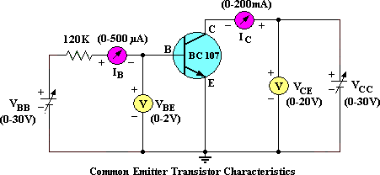

MODEL GRAPHS:

Plot the Input characteristics by taking IB on y-axis and VBE on x-axis.

Plot the Output characteristics by taking IC on the y-axis and VCE on x-axis.

INPUT CHARACTERISTICS: OUTPUT CHARACTERISTICS:

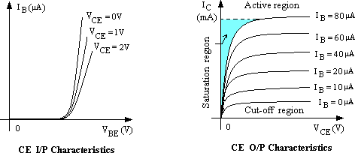

1. Measurement of h-parameters

**COMMON EMITTER TRANSISTOR CHARACTERISTICS**

**AIM:** To plot the Input and Output characteristics of a transistor connected in Common Emitter Configuration and to find the h – parameters from the characteristics.

hie= --------- ohms. hre= -----------

hoe= -------- mhos. hfe = -----------

**APPARATUS:**



|  |  |  |  |
| --- | --- | --- | --- |
| S.No | Name | Range / Value | Quantity |
| 1 | Dual Regulated D.C Power supply  Transistor | 0–30 Volts BC107 120K  (0-500A), (0-200mA)  (0-2V), (0-20V)  - | 1  1 |
| 2 |
| 3 | Resistors | 1 |
| 4 | DC Ammeters | Each 1 No |
| 5 | DC Voltmeters | Each 1 No |
| 6 | Bread Board and connecting wires | 1 Set |

**PROCEDURE:**



TO FIND THE INPUT CHARACTERISTICS:

Connect the circuit as in the circuit diagram.

Keep VBB and VCC in zero volts before giving the supply

Set VCE = 1 volt by varying VCC and vary the VBB smoothly with fine control such that base current IB varies in steps of 5μA from zero upto 200μA, and note down the corresponding voltage VBE for each step in the tabular form.

Repeat the experiment for VCE =2 volts and 4 volts.

Draw a graph between VBE Vs IB against VCE = Constant.

TO FIND THE OUTPUT CHARACTERISTICS:

Start VEE and VCC from zero Volts.

Set the IB = 20μA by using VBB such that, VCE changes in steps of 0.2 volts from zero upto 10 volts, note down the corresponding collector current IC for each step in the tabular form.

Repeat the experiment for IE = 40μA and IE = 60μA, tabulate the readings.

Draw a graph between VCE Vs IC against IB = Constant.



**TABULAR FORMS:**

INPUT CHARACTERISTICS:



|  |  |  |  |  |  |  |
| --- | --- | --- | --- | --- | --- | --- |
| S.No | VCE = 0V | | VCE = 2V | | VCE = 4V | |
| VBE (V) | IB (μA) | VBE (V) | IB (μA) | VBE (V) | IB (μA) |
|  |  |  |  |  |  |  |
|  |  |  |  |  |  |  |
|  |  |  |  |  |  |  |
|  |  |  |  |  |  |  |
|  |  |  |  |  |  |  |
|  |  |  |  |  |  |  |
|  |  |  |  |  |  |  |
|  |  |  |  |  |  |  |
|  |  |  |  |  |  |  |
|  |  |  |  |  |  |  |
|  |  |  |  |  |  |  |
|  |  |  |  |  |  |  |

OUTPUT CHARACTERISTICS;



|  |  |  |  |  |  |  |
| --- | --- | --- | --- | --- | --- | --- |
| S.No | IB = 20 | μA | IB = 40 μA | | IB = 60 μA | |
| VCE (V) | IC (mA) | VCE (V) | IC (mA) | VCE (V) | IC (mA) |
| 1 | 0.0 |  | 0.0 |  | 0.0 |  |
| 2 | 0.2 | 0.2 | 0.2 |
| 3 | 0.4 | 0.4 | 0.4 |
| 4 | 0.6 | 0.6 | 0.6 |
| 5 | 0.8 | 0.8 | 0.8 |
| 6 | 1.0 | 1.0 | 1.0 |
| 7 | 3.0 | 3.0 | 3.0 |
| 8 | 5.0 | 5.0 | 5.0 |
| 9 | 7.0 | 7.0 | 7.0 |
| 10 | 10.0 | 10.0 | 10.0 |

To find the h – parameters:

**Calculation of hie:**

Mark two points on the Input characteristics for constant VCE. Let the coordinates of these two points be (VBE1, IB1) and (VBE2, IB2).

VBE2 - VBE1 hie = ;

IB2 - IB1

**Calculation of hre:**

Draw a horizontal line at some constant IB value on the Input characteristics. Find VCE2, VCE1, VBE2, VBE1

VBE2 - VBE1

hrb = ;

VCB2 - VCB1

**Calculation of hfe:**

Draw a vertical line on the out put characteristics at some constant VCE value. Find Ic2, Ic1 and IB2, IB1 .

hfe = ;

IC2 - IC1

IB2 - IB1

**Calculation of hoe:**

On the Output characteristics for a constant value of IB mark two points with coordinates (VCE2 , IC2) and (VCE1 , IC1) .

IC2 - IC1

hob = ;

VCE2 - VCE1

**Precautions:**

**Analysis:**

**RESULTS:**

hie= --------- ohms. hre= -----------

hoe= -------- mhos. hfe = -----------

CE TRANSISTOR AMPLIFIER

**CIRCUIT DIAGRAMS:**

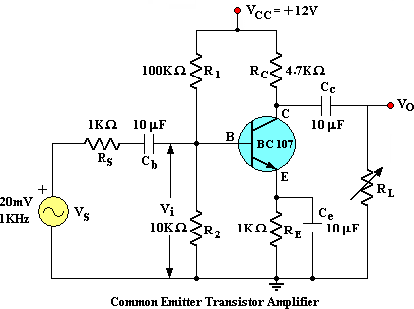

Figure.1

**MODEL GRAPH:**

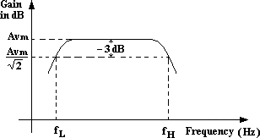

Figure.2

1. CE TRANSISTOR AMPLIFIER

**AIM**: To Find the frequency response of a Common Emitter Transistor Amplifier and to find the Bandwidth from the Response, Voltage gain, Input Resistance, output resistance.

**APPARATUS:**



|  |  |  |  |
| --- | --- | --- | --- |
| S.No | Name | Range / Value | Quantity |
| 1 | Regulated D.C Power supply | 0–30 Volts | 1 |
| 2 | Transistor | BC107 | 1 |
| 3 | Resistors | 1K | 2 |
| 4 | Resistors | 100k,10K, 4.7K. | Each 1 |
| 5 | Capacitors | 10f | 3 |
| 6 | Potentio Meter | -- | 1 |
| 7 | Signal Generator | ( 0 – 1MHz) | 1 |
| 8 | Dual Trace CRO | 20MHz | 1 |
| 9 | Bread Board and connecting wires | -- | 1 Set |

**Theory:**

**PROCEDURE:**



Connect the circuit as per the Fig.1., Apply Vcc of 12 Volts DC.

Apply I/P Voltage of 20mV at 1KHz from the Signal Generator and observe the O/P on CRO.

Vary the frequency from 50 Hz to 1MHz in appropriate steps and note down the corresponding O/P Voltage Vo in a tabular form .

Calculate the Voltage Gain Av = Vo/Vs and note down in the tabular form.

Plot the frequency (f) Vs Gain (Av) on a Semi-log Graph sheet

Draw a horizontal line at 0.707 times Av and note down the cut off points and the Bandwidth is given by B.W = f2 – f1.

**INPUT RESISTANCE RI:**

Apply I/P Voltage of 20mV at 1KHz from the Signal Generator and observe voltage Vi across R2 on CRO.

Without Disturbing the setup note Vi.

find Ii = (Vs – Vi) / Rs and Ri= Vi / Ii Ohms.

**TABULAR FORMS:**

I/P Voltage, Vs = 20mV



|  |  |  |  |  |
| --- | --- | --- | --- | --- |
| S.No | Frequency (Hz) | O/P Voltage, Vo (V) | Voltage Gain Av =Vo/Vi | Av in dB  = 20 log (Av) |
| 1 | 100 |  |  |  |
| 2 | 200 |
| 3 | 300 |
| 4 | 500 |
| 5 | 700 |
| 6 | 1K |
| 7 | 3K |
| 8 | 5K |
| 9 | 7K |
| 10 | 10K |
| 11 | 30K |
| 12 | 50K |
| 13 | 70K |
| 14 | 100K |
| 15 | 300K |
| 16 | 500K |
| 17 | 700K |
| 18 | 1M |

**OUTPUT RESISTANCE (RO):**

Apply I/P Voltage of 50mV at 1KHz from the Signal Generator and observe the o/p on CRO

Connect a Potentiometer across the O/P terminals and without disturbing Vs adjust the potentiometer such that o/p falls to V0/2

The Resistance of the potentiometer is equal to Ro.

PRECAUTIONS:

Check the wires for continuity before use.

Keep the power supply at Zero volts before Start

All the contacts must be intact

RESULT:

|  |  |  |  |  |  |
| --- | --- | --- | --- | --- | --- |
| BandWidth | | B.W | | = f2 – f1 = Hz | |
| Voltage Gain | | Av | | = | |
| Input Resistance | | Ri | | = ohms | |
| *Output Resistance* | | *Ro* | | *= ohm* | |

**Applications:** BJTs are used as amplifiers or switches to produce wide applicability in electronic equipment include mobile phones, industrial control, television, and radio transmitters

**VIVA QUESTIONS:**

What is an Amplifier?

How many types of an Amplifiers?

What is meant Band width, Lower cut-off and Upper cut-off frequency?

How much phase shift for CE Amplifier?

What are the applications?

Draw the Equivalent circuit for low frequencies?



**CIRCUIT DIAGRAM:**

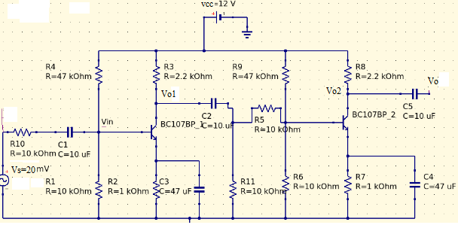

Figure 1 Two stage RC coupled amplifier



Figure 2 Model frequency response:

1. TWO STAGE RC COUPLED AMPLIFIER

**Aim:**

1. To obtain the frequency response of a two stage RC coupled amplifier

2. To calculate gain and bandwidth.

**Apparatus:**

|  |  |  |  |
| --- | --- | --- | --- |
| S.No | Name | Range | Quantity |
| 1 | Power supply | 0-30V | 1 No. |
| 2 | Transistor | BC 107 | 2 No. |
| 3 | Resistor | 1KΩ,10 KΩ,  2.2 KΩ,47KΩ | 2 No,4No,  2No,2No. |
| 4 | Capacitor | 10μF, 100μF | 4No.,2No. |
| 5 | CRO | ----- | 1No. |
| 6 | Function Generator | ----- | 1No. |
| 7 | RPS | 0-30 V | 1No. |
| 8 | Bread board | ------- | 1No. |
| 9 | Connecting wires | as per requirement | |

**Theory:**

Whenever large amplification with very good impedance matching is required using an active device such as a transistor or a field effect transistor a single active device and its associated circuitry will not be able to cater to the needs.

In such a case single stage amplifier is not sufficient and one requires more stages of amplification i.e., output of one stage is connected to the input of second stage of amplification circuit and the chain continues until the required characteristics of amplifier is achieved such an amplifier is called as multistage amplifier. In multistage amplifier, the output signal preceding stage is to be coupled to the input circuit of succeeding stage. For this inter-stage coupling different types of coupling can be employed. They are

1. RC coupling

2. Transformer coupling

3.Direct coupling

RC coupling is most popularly used type of coupling because it is cheap and provides excellent fidelity over a wide range of frequency .it is usually employed for voltage amplification. A coupling capacitor is connected to the output of first stage to the base of the input of the second stage and so on.

**TABULAR FORMS:**

Input signal Vi  =10mV ; Vs ( 1st stage) = ; Vs ( 2nd stage) =

|  |  |  |  |  |  |  |  |
| --- | --- | --- | --- | --- | --- | --- | --- |
| Sl  No. | Input Signal Frequency in Hzs | Output voltage in volts | | Gain(A) =Vo/Vi | | Gain  (in dBs)=20log(A) | |
| At 1st stage | At 2nd stage | At 1st stage | At 2nd stage | At 1st stage | At 2nd stage |
|  |  |  |  |  |  |  |  |
|  |  |  |  |  |  |  |  |
|  |  |  |  |  |  |  |  |
|  |  |  |  |  |  |  |  |
|  |  |  |  |  |  |  |  |
|  |  |  |  |  |  |  |  |
|  |  |  |  |  |  |  |  |
|  |  |  |  |  |  |  |  |
|  |  |  |  |  |  |  |  |
|  |  |  |  |  |  |  |  |
|  |  |  |  |  |  |  |  |
|  |  |  |  |  |  |  |  |
|  |  |  |  |  |  |  |  |
|  |  |  |  |  |  |  |  |
|  |  |  |  |  |  |  |  |
|  |  |  |  |  |  |  |  |
|  |  |  |  |  |  |  |  |
|  |  |  |  |  |  |  |  |
|  |  |  |  |  |  |  |  |

Determine the lower cut off frequency and upper cut off frequency from the graph and find the bandwidth.

**Procedure:**

Connect the circuit as per the circuit diagram.

By keeping the amplitude of the input signal constant, vary the frequency from (0 to 1) MHz.

Note down the amplitude of the output signal for the corresponding values of input frequencies.

Calculate the voltage gain in decibels.

Plot the graph between gain Vs frequency.

Precautions:

Analysis:

**Calculations**:

**For 1st stage :**

Calculations:

For 1st stage :

Vs=20mv,Vin=,Vo=,Ro=

Iin=(Vs-Vin)/Rs =

Input impedence(Zin)=Vin/Iin= Io=

Output impedence(Zout)=Vo/Io=

Lower cutoff frequency (fl) =.

Upper cutoff frequency (fh) =.

Bandwidth = fh-fl=

**For 2nd stage** :

Calculations:

For 1st stage :

Vs=20mv,Vin=,Vo=,Ro=

Iin=(Vs-Vin)/Rs =

Input impedence(Zin)=Vin/Iin= Io=

Output impedence(Zout)=Vo/Io=

Lower cutoff frequency (fl) =.

Upper cutoff frequency (fh) =. Bandwidth = fh-fl=

**Result:**

**Applications:** They have excellent audio fidelity over a wide range of frequency.

Widely used as Voltage amplifiers.

Disadvantages:Due to poor impedance matching, RC coupling is rarely used in the final stages.

Viva Questions:

What is the necessity of cascading?

Define 3-dB bandwidth.

Why RC-coupling is preferred in audio range.

Explain various types of capacitors.

What is loading effect?

What is meant by RC coupling?

**CIRCUIT DIAGRAM:** Double Ended Mode:

Figure 1

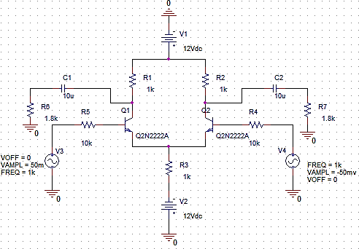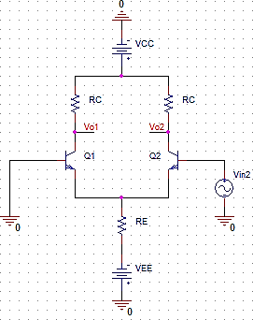

Single input mode and inverting and non-inverting outputs

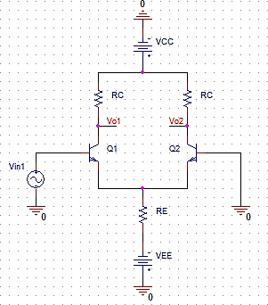

1. Differential Amplifier

**Aim:**

To understand the DC and AC operation of a differential amplifier. To measure DC voltages and currents in differential amplifier.

To obtain measured values of differential-mode gain 𝐴𝑣𝑑𝑚, common-mode gain 𝐴𝑣𝑐𝑚

and common-mode rejection ratio 𝐶𝑀𝑅𝑅.

**Equipment Required:**

|  |  |  |  |
| --- | --- | --- | --- |
| S.No | Name | Range | Quantity |
| 1 | Fixed Power supply | 12V | 1No. |
| 2 | Transistor | BC 107 /QN2222 | 2 No. |
| 3 | Resistor | 1KΩ,10 KΩ,100 KΩ,  1.8KΩ,47KΩ | 4No,4No,  4No,4No. |
| 4 | Capacitor | 10μF, 100μF | 4No.,2No. |
| 5 | CRO | ----- | 1No. |
| 6 | Function Generator | 2MhZ | 2No. |
| 7 | RPS | 0-30 V | 1No. |
| 8 | Bread board | ------- | 1No. |
| 9 | Connecting wires | as per requirement | |

**Theory:**

Differential amplifiers circuit constructing from two bipolar junction transistor (BJT), so that have two separated inputs and outputs pins with common emitter pin as shown in figure

𝑉𝑜 = 𝐴𝑣 ∗ (𝑉𝑖𝑛1 − 𝑉𝑖𝑛2)

**Tabularforms:**

Applied all differential amplifier modes.

Single-input mode:

|  |  |  |  |
| --- | --- | --- | --- |
| Vin1 | Vin2 | Vo1 | Vo2 |
| 50mv | 0 |  |  |
| 0 | 50mv |  |  |

Double input mode:

|  |  |  |  |
| --- | --- | --- | --- |
| Vin1 | Vin2 | Vo1 | Vo2 |
| 50mv | 50mv |  |  |
| 100mv | 50mv |  |  |
| 200mv | 300mv |  |  |

Common input mode:

|  |  |  |
| --- | --- | --- |
| Vin | Vo1 | Vo2 |
| 50mv |  |  |
| 0 |  |  |

Differential amplifiers it is a type of electronics amplifier that multiplies the difference between two input signals by constant factor.

Differential amplifiers are thereby able to reduce noise that is common to both inputs, only amplifying the differential signal that we are interested in.

Differential amplifier is a basic circuit which used in all linear integrated circuit (IC), and it also a basic circuit in analog to digital and digital to analog converter circuits.

Differential amplifiers circuit constructing from two bipolar junction transistor (BJT), so that have two separated inputs and outputs pins with common emitter pin as shown in figure

𝑉𝑜 = 𝐴𝑣 ∗ (𝑉𝑖𝑛1 − (−𝑉𝑖𝑛2))

𝑉𝑜 = 𝐴𝑣 ∗ (𝑉𝑖𝑛1 − 𝑉𝑖𝑛2)

**Precautions:** 1. Vary the input signal frequency slowly.

2. Connect electrolytic capacitors carefully.

**Analysis:**

**Result:**

**Applications:** The amplifier which amplifies the difference between two input signals is called as Differential amplifier.

The differential amplifier configuration is very much popular and it is used in variety of analog circuits.

It is basic building in operational amplifier. signal amplification applications, controlling of motors & servo motors, input stage emitter-coupled logic, switch, and so on are common applications of the differential amplifier circuit.

**CIRCUIT DIAGRAMS:**

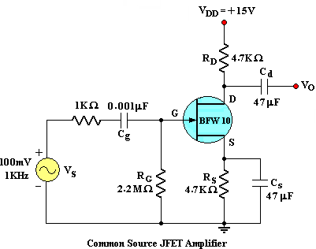

Figure 1



Figure 2

1. COMMON SOURCE FET AMPLIFIER

**AIM:** To study the frequency response of a Common Source Field Effect Transistor and to find the Bandwidth from the Response.

APPARATUS:



|  |  |  |  |
| --- | --- | --- | --- |
| **S.No** | **Name** | **Range / Value** | **Quantity** |
| 1 | Regulated D.C Power supply | 0–30 Volts | 1 |
| 2 | JFET | BFW10 or 11 | 1 |
| Signal Generator | (0 – 1MHz) | 1 |
| 3 |
| 4 | Resistors | 1KΩ, 2.2 MΩ, 4.7 KΩ, 470 Ω. | Each 1 |
| 5 | Capacitors | 47 μf | 2 |
| 6 | Capacitors | 0.001μf | 1 |
| 7 | Bread Board and connecting wires | - | 1 Set |
| 8 | Dual Trace CRO | 20MHz | 1 No |

**Theory:**

A FET amplifier is an amplifier that uses one or more field-effect transistors (FETs). The most common type of FET amplifier is the MOSFET amplifier, which uses metal–oxide–semiconductor FETs (MOSFETs). The main advantage of a FET used for amplification is that it has very high input impedance and low output impedance.

**PROCEDURE:**



Connect the circuit as per the Fig.

Keep I/P Voltage at 100mV.

Vary the frequency from 50 Hz to 1MHz in appropriate steps and note down the corresponding source voltage Vs and o/p Voltage Vo in a tabular Form .

Plot the frequency (f) Vs Gain (Av) on a semi-log graph sheet and determine the Bandwidth. From the graph.

|  |  |  |  |  |
| --- | --- | --- | --- | --- |
| S.No | Frequency (Hz) | O/P Voltage, Vo (V) | Voltage Gain Av =Vo/Vi | Av in dB  = 20 log (Av) |
| 1 | 50 |  |  |  |
| 2 | 100 |
| 3 | 200 |
| 4 | 300 |
| 5 | 500 |
| 6 | 700 |
| 7 | 1K |
| 8 | 3K |
| 9 | 5K |
| 10 | 7K |
| 11 | 10K |
| 12 | 30K |
| 13 | 50K |
| 14 | 70K |
| 15 | 100K |
| 16 | 300K |
| 17 | 500K |
| 18 | 700K |
| 19 | 1M |

TABULAR FORMS:

I/P Voltage, Vs = 100mV



**PRECAUTIONS:**

Check the wires for continuity before use.

Keep the power supply at Zero volts before Start

For a good JFET ID will be  11.0 mA at VGS = 0.0 Volts if not change the JFET.

**Analysis:**

**RESULT:**

**Applications:** FETs are voltage-sensitive devices with high input impedance (on the order of 107 to 1012 Ω). ...

One class of FETs (JFETs) generates lower noise than BJTs.

FETs are more temperature stable than BJTs.

FETs are generally easier to fabricate than BJTs.

**Result:**

BandWidth , B.W = f2 – f1 = Hz

**VIVA QUESTIONS**:

What are the advantages of JFET over BJT?

Why input resistance in FET amplifier is more than BJT amplifier

What is a Uni-polar Device?

What is Pinch off Voltage?

What are the various FETs?

What is Enhancement mode and depletion mode?

Draw the equivalent circuit of JFET for Low frequencies

Write the mathematical equation for gm in terms of gmo.

Write equation of FET ID in terms of VGS and VP.

**CIRCUIT DIAGRAM: figure1**

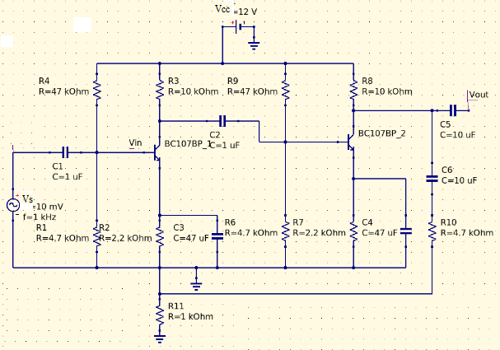

Model graph for frequency response:



Figure 2

1. VOLTAGE-SERIES FEEDBACK AMPLIFIER

**Aim:** - To obtain the frequency response of a voltage series feedback amplifier and also find its following characteristics voltage series gain (Av), current gain (Ai), input impedance (Zin), Output impedance (Zo) and bandwidth Compare the above calculated values with the values of without feedback amplifier.

**Apparatus:**

|  |  |  |  |
| --- | --- | --- | --- |
| S.No | Name | Range | Quantity |
| 1 | Power supply | 0-30V | 1 No. |
| 2 | Transistor | BC 107 | 2 No. |
| 3 | Resistor | 1KΩ, 10 KΩ,4.7 KΩ,47 KΩ, 2.2KΩ | 1 No,2NO,3NO,  1 No,2NO. |
| 4 | Capacitor | 47 μF,10 μF, 1 μF | 2No,2NO, 2NO. |
| 7 | Bread board | ------- | 1 No. |
| 8 | Signal Generator | ------- | 1No. |
| 9 | Connecting wires | as per requirement | |

**Theory**: Voltage-Series feedback amplifier is a one type of negative feedback amplifier. Series connection at input increases input resistance and shunt connection at output reduces output resistance. The resulting amplifier is a true voltage amplifier.

**Procedure:**

Design the circuit as per the given specifications and connect the circuit as per the circuit diagram.

Without giving any input, connect VCE and measure VCC and IC and compare them with VCE and ICQ.

Keep VS at 20 mV, using the signal generator measure the Vi at base.

Keeping the input voltage constant, vary the frequency from 50Hz to 1MHz in regular steps and note down the corresponding output voltage of amplifier without feedback (i.e., with bypass filter).

|  |  |  |  |  |  |  |  |
| --- | --- | --- | --- | --- | --- | --- | --- |
| Sl  No. | Input Signal Frequency in Hzs | Output voltage in volts | | Gain(A) =Vo/Vi | | Gain  (in dBs)=20log(A) | |
| With feedback | Without feed back | With feedback | Without feed back | With feedback | Without feed back |
|  |  |  |  |  |  |  |  |
|  |  |  |  |  |  |  |  |
|  |  |  |  |  |  |  |  |
|  |  |  |  |  |  |  |  |
|  |  |  |  |  |  |  |  |
|  |  |  |  |  |  |  |  |
|  |  |  |  |  |  |  |  |
|  |  |  |  |  |  |  |  |
|  |  |  |  |  |  |  |  |
|  |  |  |  |  |  |  |  |
|  |  |  |  |  |  |  |  |
|  |  |  |  |  |  |  |  |
|  |  |  |  |  |  |  |  |
|  |  |  |  |  |  |  |  |
|  |  |  |  |  |  |  |  |
|  |  |  |  |  |  |  |  |
|  |  |  |  |  |  |  |  |
|  |  |  |  |  |  |  |  |
|  |  |  |  |  |  |  |  |
|  |  |  |  |  |  |  |  |

**Observations:**

Input signal Vi  = ; Vs ( With feedback) = ; Vs ( Without feedback) =

**Calculations:**

**Amplifier with feedback**

Vs=20mV, Rs=1KΩ, Vi=, Vo= , Ro=

Maximum voltage gain (AVMax) =Vo/Vin=

Current gain Ai  =Io/Iin=

Input impedence (zl) =Vin/Iin=

Ouput impedence (z0) =Vo/Io=

Bandwidth =

**Amplifier without feedback**

Ouput impedence (z0) =Vo/Io=

Bandwidth =

Maximum voltage gain (AVMax) =Vo/Vin=

Current gain Ai  =Io/Iin=

Input impedence (zl) =Vin/Iin=

Ouput impedence (z0) =Vo/Io=

Bandwidth =

Vs=20mV, Rs=1KΩ, Vi=, Vo= , Ro=

Maximum voltage gain (AVMax) =Vo/Vin=

Current gain Ai  =Io/Iin=

Input impedence (zl) =Vin/Iin=

Ouput impedence (z0) =Vo/Io=

Bandwidth =

**comparison table:**

|  |  |  |
| --- | --- | --- |
| Parameter | Without feedback | With Feedback |
| Vout |  |  |
| Vin |  |  |
| Av = Vout/Vin |  |  |
| Iout=Vout/Zout |  |  |
| Iin |  |  |
| Ai=Iout/Iin |  |  |
| Z0=Ro |  |  |
| Zin=Rin=Vin/Iin |  |  |
| Bandwidth |  |  |

**Precautions:**

**Analysis:**

**Applications:** Application of voltage series feedback amplifier is that it can be used as a source follower

(which is called as the drain characteristics) and emitter follower (where the input impedance is high

whereas the output impedance is low which is good for frequency response) from which the feedback gain,

input resistance and output resistance is determined.

**Result:**

**Viva Questions:**

What is meant by Feedback?

What are the types of feedback amplifiers? Explain?

Draw the circuit for voltage series feedback?

What are the differences between positive and negative feedback?

What is the effect of negative feedback on gain of an amplifier?

What is the formula for voltage gain with negative feedback?

What are the other names for positive and negative feedback circuits?

What is the formula for input resistance of a voltage series feedback?

What is the formula for output resistance of a voltage series feedback?

CIRCUIT DIAGRAM:

FIGURE 1

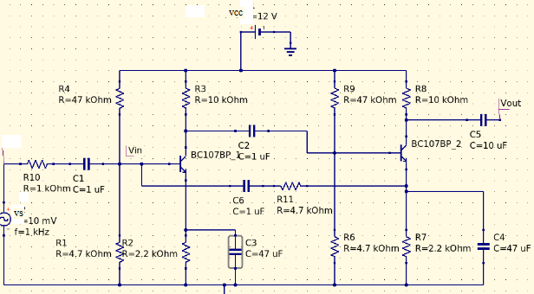



FIGURE 2

Model graph for frequency response:

1. CURRENT-SHUNT FEEDBACK AMPLIFIER

**Aim:** - To obtain the frequency response of a current shunt feedback amplifier and also find its

Following characteristics

voltage series gain (Av), current gain (Ai), input impedance (Zin), Output impedance (Zo) and bandwidth

Compare the above calculated values with the values of without feedback amplifier.

**Apparatus**:

|  |  |  |  |
| --- | --- | --- | --- |
| S. No | Components | Range | Quantity |
| 1. | Trainer Kit | -------- | 1No |
| 2. | Transistor | BC 107 | 2NO |
| 3. | Resistors | 1KΩ,2.2KΩ,4.7kΩ,  47KΩ,1.5kΩ, 10kΩ, | 1No,1NO,3NO,  2NO,2NO,2NO |
| 4. | Capacitors | 10µF, 47µF | 3NO,1NO |
| 5. | Function generator | -------- | 1NO |
| 6. | C.R.O. | -------- | 1NO |

**Theory**:

Current-Shunt topology of the feedback amplifier is a one type of negative feedback amplifier. Feedback signal is proportional to the output current and feedback to input in shunt. The series connection at the output increases output resistance and shunt connection at input decreases input resistance. The amplifier works as a true current amplifier

**Procedure:**

1. Design the circuit as per the given specifications and connect the circuit as per the circuit diagram.
2. Without giving any input, connect VCE and measure VCC and IC and compare them with VCE and ICQ.
3. Keep VS at 20 mV, using the signal generator measure the Vi at base.
4. Keeping the input voltage constant, vary the frequency from 50Hz to 1MHz in regular steps and note down the corresponding output voltage of amplifier without feedback(i.e., with bypass filter).
5. Plot the graph between gain (dB) and frequency and calculate the bandwidth.
6. Find the voltage gain, current gain, input and output impedances by following the procedure given below and compare the values of feedback with the values of amplifier without feedback.

**Tabularforms:**

Input signal Vi  =10mV ; Vs ( With feedback) = ; Vs ( Without feedback) =

|  |  |  |  |  |  |  |  |
| --- | --- | --- | --- | --- | --- | --- | --- |
| Sl  No. | Input Signal Frequency in Hzs | Output voltage in volts | | Gain(A) =Vo/Vi | | Gain  (in dBs)=20log(A) | |
| With feedback | Without feed back | With feedback | Without feed back | With feedback | Without feed back |
|  |  |  |  |  |  |  |  |
|  |  |  |  |  |  |  |  |
|  |  |  |  |  |  |  |  |
|  |  |  |  |  |  |  |  |
|  |  |  |  |  |  |  |  |
|  |  |  |  |  |  |  |  |
|  |  |  |  |  |  |  |  |
|  |  |  |  |  |  |  |  |
|  |  |  |  |  |  |  |  |
|  |  |  |  |  |  |  |  |
|  |  |  |  |  |  |  |  |
|  |  |  |  |  |  |  |  |
|  |  |  |  |  |  |  |  |
|  |  |  |  |  |  |  |  |
|  |  |  |  |  |  |  |  |
|  |  |  |  |  |  |  |  |
|  |  |  |  |  |  |  |  |
|  |  |  |  |  |  |  |  |
|  |  |  |  |  |  |  |  |
|  |  |  |  |  |  |  |  |

**Calculations:**

Amplifier with feedback

Vs=20mV, Rs=1KΩ, Vi=, Vo=, Ro=

Maximum voltage gain (AVMax) =Vo/Vin=

Current gain Ai  =Io/Iin=

Input impedence (zl) =Vin/Iin=

Ouput impedence (z0) =Vo/Io=

Bandwidth =

Amplifier without feedback

Vs=20mV, Rs=1KΩ, Vi=, Vo=, Ro=

Maximum voltage gain (AVMax) =Vo/Vin=

Current gain Ai  =Io/Iin=

Input impedence (zl) =Vin/Iin=

Ouput impedence (z0) =Vo/Io=

Bandwidth =

Comparison table:

|  |  |  |
| --- | --- | --- |
| Parameter | Without feedback | With Feedback |
| Vout |  |  |
| Vin |  |  |
| Av = Vout/Vin |  |  |
| Iout=Vout/Zout |  |  |
| Iin |  |  |
| Ai=Iout/Iin |  |  |
| Z0=Ro |  |  |
| Zin=Rin=Vin/Iin |  |  |
| Bandwidth |  |  |

**Precautions:**

**Analysis:**

**Result:**

**Applications:** In the current shunt feedback topology, the amplifiers input resistance decreases and the output resistance decreases because of its connectivity of the input, output and feedback circuit.

**Viva Questions:**

What is meant by Feedback?

What are the types of feedback amplifiers? Explain?

Draw the circuit for voltage series feedback?

What are the differences between positive and negative feedback?

What is the effect of negative feedback on gain of an amplifier?

What is the formula for voltage gain with negative feedback?

What are the other names for positive and negative feedback circuits?

What is the formula for input resistance of a current shunt feedback?

What is the formula for output resistance of a current shunt feedback?

**CIRCUIT DIAGRAM:**

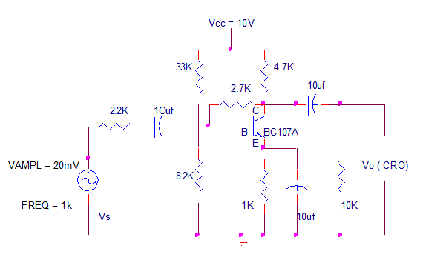

FIGURE1

SVOLTAGE SHUNT AMPLIFIER WITH FEEDBACK

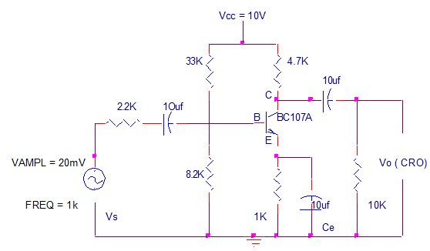

FIGURE2

VOLTAGE SHUNT AMPLIFIER WITH OUT FEEDBACK

**VOLTAGE SHUNT FEEDBACK AMPLIFIER**

**AIM**:

To obtain the frequency response of a voltage shunt feedback (with and without) amplifier and obtain the bandwidth.

**APPARATUS:**

|  |  |  |
| --- | --- | --- |
| :  Power supply | 0-30V | 1No. |
| CRO | 20MHz | 1No. |
| Signal generator | 1-1MHz | 1 No |
| Resistors | 1kΩ,4.7k,8.2k | 1 No |
| Resistors | 2.2k,33k,10K,2.7K | 1 No |
| Capacitors | 10µF | 3 No , |
| Transistors Bread board  CRO Probes | BC107 | 1 No |

##### **Theory****:**

##### In the voltage shunt feedback circuit, a fraction of the output voltage is applied in parallel with the input voltage through the feedback network. ... As the feedback circuit is connected in shunt with the output and the input as well, both the output impedance and the input impedance are decreased.

**WITH FEEDBACK: I/P VOLTAGE Vi =**

|  |  |  |
| --- | --- | --- |
| **FREQUENCY (Hz)** | **O/P VOLTAGE (Vo)** | **Gain in dB = 20 log Vo / Vi** |
| **100** |  |  |
| **200** |
| **300** |
| **500** |
| **700** |
| **1k** |
| **2k** |
| **3k** |
| **5k** |
| **7k** |
| **10k** |
| **20k** |
| **30k** |
| **50k** |
| **70k** |
| **100k** |
| **200k** |
| **300k** |
| **500k** |
| **700k** |
| **1M** |

.

##### **PROCEDURE:**

1. Connections are made as per the circuit diagram.
2. A 10V DC supply is given to the circuit for biasing.

3 . The circuit is connected without feedback i.e., without RF

1. A certain amplitude of input signal (say 20mV) is kept constant using the

function generator and for different frequencies the output voltage from CRO are noted.

1. Now, the circuit is connected with feedback i.e., with RF.
2. By keeping the input signal constant, the output voltages for different frequencies are noted from CRO.
3. Gain with and without feedback is calculated from the formula

**Gain = 20 log Vo / Vi (dB)**

##### **PRECAUTIONS :**

* + - Avoid loose and wrong connections.
    - Avoid parallax error while taking readings.

**Analysis:**

**WITHOUT FEEDBACK: I/P VOLTAGE Vi =**

|  |  |  |
| --- | --- | --- |
| **FREQUENCY (Hz)** | **O/P VOLTAGE (Vo)** | **Gain in dB = 20 log Vo / Vi** |
| **100** |  |  |
| **200** |
| **300** |
| **500** |
| **700** |
| **1k** |
| **2k** |
| **3k** |
| **5k** |
| **7k** |
| **10k** |
| **20k** |
| **30k** |
| **50k** |
| **70k** |
| **100k** |
| **200k** |
| **300k** |
| **500k** |
| **700k** |
| **1M** |

##### **MODEL GRAPH :**

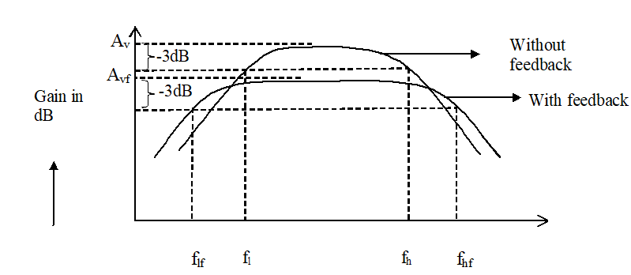

**BANDWIDTH:FH-FL**

**GRAPH** : A graph is plotted between gain (dB) and frequency(Hz) which is frequency response of voltage shunt feedback amplifier for without feedback and with feedback

##### **RESULT:**

**Applications:** The feedback applied to the input increases the input signal that can be a voltage signal. This is referred to as the positive type. It is also known as a direct amplifier. But these kinds of amplifiers are not good at amplification but can be used in the various types of oscillators.

**Viva Questions:**

1. What is the relationship between the transfer gain with feedback Af and that without feedback A.

A. Af=A/(1+Aβ)

1. What are the advantages of negative feedback.
   1. High BW, less noise, less distortion, gain stability
2. How is the i/p impedance and o/p impedance of a voltage shunt feedback amplifier
   1. Rif = Ri/(1+Aβ), Rof =Ro/(1+Aβ)
3. What are the types of feedback amplifiers.
   1. Voltage shunt, current shunt, current series, voltage series feedback amplifiers.

**CIRCUIT DIAGRAM**S: -

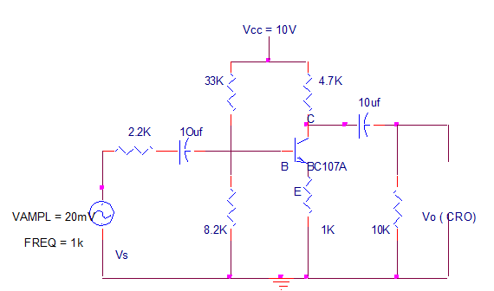

Figure 1

CURRENT SERIES AMPLIFIER WITH FEEDBACK

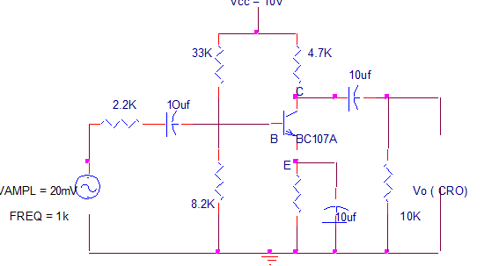

Figure 2

CURRENT SERIES AM PLIFIER WITHOUT FEEDBACK

CURRENT SERIES FEEDBACK AMPLIFIER

**AIM:** To obtain the frequency response characteristics of a Current Series amplifier with and without feedback and Obtain the bandwidth.

Where Vo is output voltage, Vi is input voltage.

TABULAR FORM : WITH FEEDBACK Vi =

|  |  |  |
| --- | --- | --- |
| **FREQUENCY (Hz)** | **O/P VOLTAGE (Vo)** | **Gain in dB = 20 log Vo / Vi** |
| **100** |  |  |
| **200** |
| **300** |
| **500** |
| **700** |
| **1k** |
| **2k** |
| **3k** |
| **5k** |
| **7k** |
| **10k** |
| **20k** |
| **30k** |
| **50k** |
| **70k** |
| **100k** |
| **200k** |
| **300k** |
| **500k** |
| **700k** |
| **1M** |

PROCEDURE :

1. Connections are made as per the circuit diagram.

2. A 10V supply is given to the circuit.

3. The circuit is connected for with feedback, i.e., without bypass capacitor.

4. A certain amplitude of input signal is kept constant using signal generator and for

different frequencies, the output voltage from CRO are noted.

5. Now, the circuit is connected for without feedback i.e., with bypass capacitor CE and RE in

the circuit.

6. By keeping the input signal constant, the output voltage for different frequencies are

noted.

7. Gain for with and without feedback is calculated using

Gain = 20 log Vo / Vi (dB)

TABULAR FORM: WITH OUT FEEDBACK Vi =

|  |  |  |
| --- | --- | --- |
| **FREQUENCY (Hz)** | **O/P VOLTAGE (Vo)** | **Gain in dB = 20 log Vo / Vi** |
| **100** |  |  |
| **200** |
| **300** |
| **500** |
| **700** |
| **1k** |
| **2k** |
| **3k** |
| **5k** |
| **7k** |
| **10k** |
| **20k** |
| **30k** |
| **50k** |
| **70k** |
| **100k** |
| **200k** |
| **300k** |
| **500k** |
| **700k** |
| **1M** |

**MODEL GRAPH:**



**Bandwidth FH-FL**

**GRAPH:** A graph is plotted between gain (dB) and frequency (Hz) for both with and without feedback.

**PRECAUTIONS:** 1. Connections must be made with proper polarity. 2. Avoid loose and wrong connections.

**Analysis:**

**Result:**

**Applications:**

In the current series feedback circuits, both the input and the output resistances are increased because of its topology. In the current shunt feedback topology, the amplifiers input resistance decreases and the output resistance decreases because of its connectivity of the input, output and feedback circuits.

**VIVA QUESTIONS:**

1. What is the relationship between the transfer gain with feedback Af and that without

feedback A.

A. Af =A /(1+Aβ)

2. Define negative feedback.

A. The amout of feedback applied is subtracted from the input to get negative feedback.

3. What are the advantages of negative feedback.

A. High BW,less noise,less distortion,gain stability

4. How is the i/p impedance and o/p impedance of a current shunt feedback amplifier

A. Rif = Ri/(1+Aβ), Rof =Ro(1+Aβ)

The frequency response characteristics of current series amplifier with & with

**CIRCUIT DIAGRAM:**

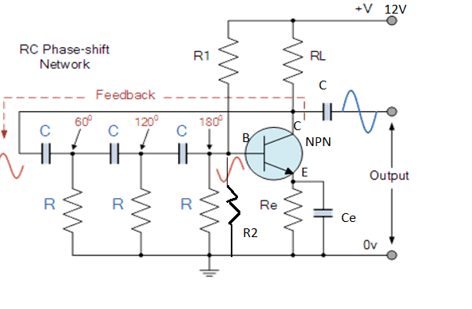

FIGURE 1

RC PHASE SHIFT OSCILLATOR

RC PHASE SHIFT OSCILLATOR

**Aim:** To design and construct the RC phase shift oscillator for given frequency and verify its frequency of oscillations.

**Apparatus:**

|  |  |  |  |
| --- | --- | --- | --- |
| S.No | Name | Range | Quantity |
| 1 | Power supply | 0-30V/+12V((fixed) | 1 No. |
| 2 | Transistor | BC 107/ BC 547 | 1 No. |
| 3 | Resistor | 10 KΩ,4.7 KΩ,  5.6 KΩ,,3.3 KΩ,33 KΩ,  560Ω/220Ω,1KΩ,2.2 KΩ | 1 No. |
| 4 | Capacitor | 0.1μF, 10μF, 47μF | 3No, 1No, 1No. |
| 5 | CRO | ----- | 1 No. |
| 6 | RPS | 0-30 V | 1No. |
| 7 | Bread board | ------- | 1 No. |
| 9 | Connecting wires | as per requirement | |

**Theory**:

RC phase shift oscillator consists of a conventional single transistor amplifier and a RC phase shift network .The phase shift network consists of three sections R1,C1,R2,C2 and R3,C3 .At some particular frequency fo, the phase shift in each RC section in 60o so that the total phase shift produced by the RC network is 180o. The frequency is given by

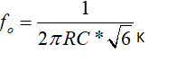

K=RC/R

When the circuit is switched on it produces oscillations of frequency fo .The output fo of the amplifier is feedback to RC feedback network .This network produces a phase shift of 180o and a voltage Ear appears at its output which is applied to transistor amplifier. A phase shift of 180o is produced by the transistor amplifier. A further 180o is produced by the RC network the phase shift around the entire loop is 360o hence Bark-hausen condition is satisfied.

**TABULAR FORM:**

|  |  |
| --- | --- |
| Theoretical value | Practical Value |
| 1.design for 1kHzs | Amplitude=  Timeperiod=  fo=1/T= |

**Observations:**



Where RC/R=K

Model Waveform: Figure 2

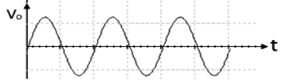

**Procedure:**

Connect the circuit as per the circuit diagram.

Switch on the power supply and set to 12V.

Calculate the amplitude and frequency from CRO.

Compare the frequency obtained with the theoretical value.

Draw the graph of the output waveform between amplitude and time period.

**Precautions**:

**Analysis:**

**Applications:** This phase shift oscillator is used to generate the signals over an extensive range of frequency. They used in musical instruments, GPS units, & voice synthesis.

The applications of this phase shift oscillator include voice synthesis, musical instruments, and GPS units.

**Result:**

**Viva Questions:**

Mention the conditions for oscillations in RC phase shift oscillator?

Give the formula for frequency of oscillations in RC phase shift oscillator?

The phase produced by a single RC network is RC phase shift oscillator?

RC phase shift oscillator uses positive feedback or negative feedback?

The phase produced by basic amplifier circuit in RC phase shift oscillator is?

What is the difference between damped oscillations un-damped oscillations?

What are the applications of RC oscillations?

**CIRCUIT DIAGRAM:** Wein bridge oscillator

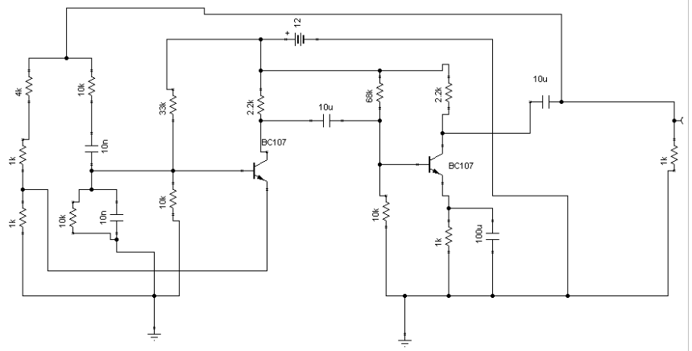

Figure 1

Wein bridge oscillator

**Aim:**To study and calculate frequency of oscillations of Wein Bridge Oscillator and compare it with theoretical value.

**APPARATUS:**

|  |  |  |  |
| --- | --- | --- | --- |
| S.No | Name | Range / Value | Quantity |
| 1 | Fixed Power supply | 12 Volts | 1 |
| 2 | Transistor | BC107 | 1 |
| 3 | Resistors | 1K | 2 |
| 4 | Resistors | 100k,10K, 4.7K.1K,2.2K,33K,68K | Each 1 |
| 5 | Capacitors | 10f,100uf,1nf,0.01uf | 3 |
| 6 | Potentio Meter | -- | 1 |
|  |  |  | 1 |
| 7 | Dual Trace CRO | 20MHz | 1 |
| 8 | Bread Board and connecting wires | -- | 1 Set |

**THEORY:**

The Wein Bridge oscillator is a standard circuit for generating low frequencies in the range of 10 Hz to 1MHz.The method used for getting +ve feedback in Wein Bridge oscillator is to use two stages of an RC-coupled amplifier. Since one stage of the RC-coupled amplifier introduces a phase shift of 180 deg, two stages will introduces a phase shift of 360 deg. At the frequency of oscillations *f* the +ve feedback network shown in fig makes the input & output in the phase.

The formula for frequency of oscillations is given as

*f =1/2pvR1C1R2C2*

If R1C1 = R2.C2 = RC, then f = 1/2*p* RC

In the above circuit, f=1/2p*v R4C2R7C1*

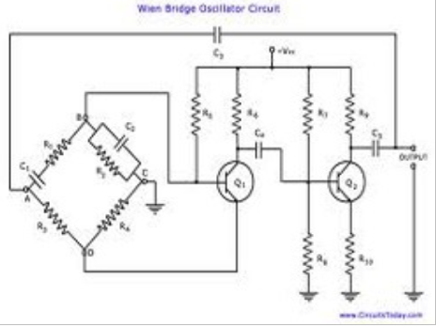

**CIRCUIT DIAGRAM:** Wein bridge oscillator

Figure 2

**PROCEDURE:**

Start Tina. A blank circuit window will appear on the screen along with a component tool bar.

Using component tool bar place all the components on the circuit window and wire the circuit.

By making adjustments in the Potentiometer connected in the +ve feedback loop, try to obtain a stable sine wave.

Measure the time period of the waveform obtained on CRO and calculate the Frequency of oscillations.

Repeat the procedure for different values of capacitance.

Amplitude,V0**=**

**Precautions:**

**OBSERVATION:**

Given R=10kO, C=0.01µF

fT= 1/ 2(pi)RC=

fP= 1/T

**TABULAR FORM:**

|  |  |
| --- | --- |
| Theoretical value | Practical Value |
| 1.design frequency | Amplitude=  Timeperiod=  fo=1/T= |

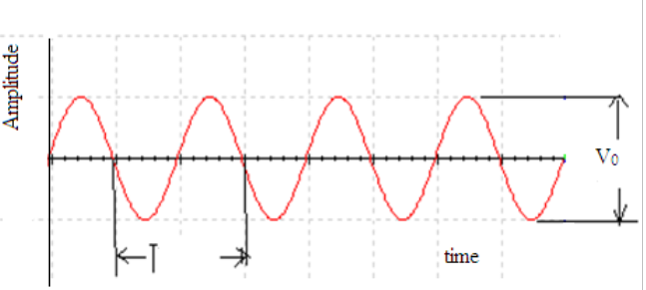

**MODEL WAVE FORMS:** Figure 3

**Analysis:**

**RESULT:**

**Applications:**

**It is used to measure the audio frequency.**

**Wien bridge oscillator designs the long range of frequencies.**

**It produces sine wave.**

**VIVA QUESTIONS:**

1.Give the formula for frequency of oscillations in Wein Bridge Oscillator circuit?

Ans:

2.What is the condition for Wien Bridge oscillator to generate oscillations?

Ans:

What is the total phase shift provided by the Wein Bridge oscillator?

What is the function of lead-lag network in Wein Bridge oscillator?

Which type of feedback is used in Wein Bridge oscillator

What is the gain of Wein Bridge oscillator?

What are the applications of Wein Bridge oscillator

What is the condition for generating oscillations?

What is the difference between damped oscillations undamped oscillations?

Wein Bridge oscillator is either LC or RC oscillator.

What are the drawbacks in using Wein Bridge Oscillators?

**CIRCUIT DIAGRAM**

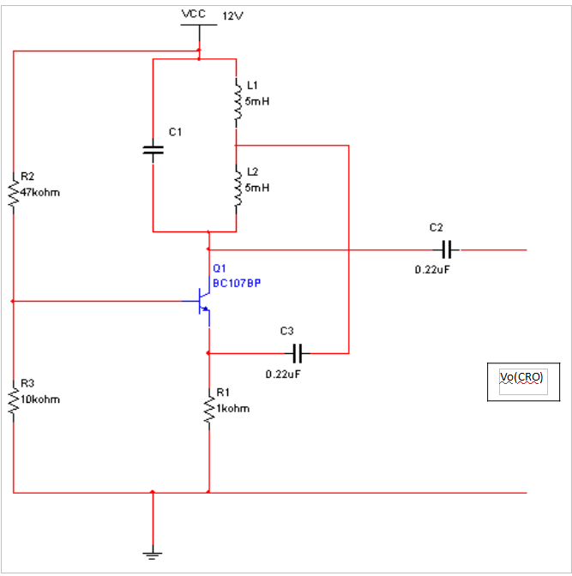

Hartly oscilattor

Figure1

**Hartly oscilattor**

**Aim:** To study and calculate frequency of oscillations of Hartley oscillator. Compare the frequency of oscillations, theoretically and practically.

**APPARATUS:**

Transistor    BC 107 -1 No.

Capacitors   0.1µF, 10 µF -1 No. each

                       0.22 µF -2 Nos

Resistors     47Kohms, 1Kohms and 10Kohms -1 No.

Decade inductance box (DIB) -1 No.

Decade resistance box (DRB) -1 No.

Inductors : 5mH – 2 Nos.

CRO(Dual Channel ) (0-20 MHz)

Function generator ( 1Hz to 1 MHz)

Regulated power supply (0-30V)

Bread board

Connecting wires

**THEORY:**

Hartley oscillator is very popular and is commonly used as a local oscillator in radio receivers. It has two main advantages viz… Adaptability to wide range of frequencies and easy to tune. The tank circuit is made up of L1, L2, and C1. The coil L1 is inductively coupled to coil L2, the combination of two functions acts as auto transformer. The resistances R2 and R3 provide the necessary biasing. The capacitance C2 blocks the d.c component. The frequency of oscillations is determined by the values of L1, L2 and C1 and is given by,

F=1/(2(Pi)(C1(vL1+L2)))

The energy supplied to the tank circuit is of correct phase. The auto transformer ( L1 and L2 forms as an auto transformer) provides 180o out of phase. Also another 180ois produced by the transistor. In this way, energy feedback to the tank circuit is in phase with the generated oscillations

**PROCEDURE:**

1. Connections are to be made as per the circuit diagram properly (C1 value to be selected as 0.1µF and10µF as required).

2. Connect CRO at output terminals and observe the wave form.

3. Calculate practically the frequency of oscillations by using the expression.

f=1/T, Where T= Time period of the waveform

4. Repeat the above steps 2, 3 for different values of L1 and note down practical values of oscillations of Hartley oscillator.

5. Compare the values of frequency of oscillations both theoretically and Practically.

**Tabular form:**

**OBSERVATIONS:**

|  |  |  |
| --- | --- | --- |
| **CAPACITANCE(µF)** | **Theoretical frequency**  **(KHz)** | **Practical frequency**  **(KHz)** |
|  |  |  |
|  |  |  |
|  |  |  |

**MODEL GRAPH:**

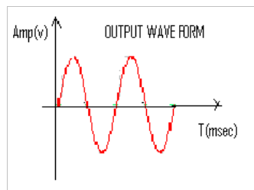

Figure 2

**PRECAUTIONS:**

All the connections are to be connected properly.

Transistor terminals must be identified properly.

Reading should be taken without any parallax error.

**Analysis:**

**RESULT:**

**Applications:** The Hartley oscillator is to produce a sine wave with the desired frequency.

Hartley oscillators are mainly used as radio receivers. Also note that due to its wide range of frequencies, it is the most popular oscillator.

The Hartley oscillator is Suitable for oscillations in RF (Radio-Frequency) range, up to 30MHZ.

Viva questions:

What are the applications of LC oscillator?

What type of feedback is used in oscillators?

What is the loop gain of an oscillator?

What is the difference between amplifier and oscillator?

What is the condition for oscillations?

CIRCUIT DIAGRAM:

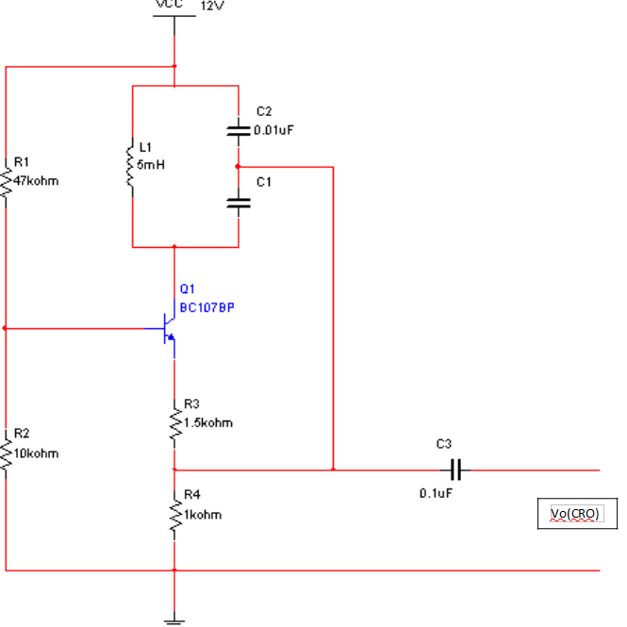

Figure 1

Colpitts oscillator

**Aim**: To study and calculate frequency of oscillations of Colpitt’s oscillator.

**APPARATUS:**

Transistor BC 107 -1 No.

Capacitors 0.1µF - 1 No, 0.01µF - 2 Nos

Inductor 5mH - 1 No.

Resistors  47KOhm, 1kO, 10kO, 1.5K -1 No.

Decade inductance box

CRO(Dual Channel ) (0-20 MHz)

Function generator ( 1Hz to 1 MHz)

Regulated power supply (0-30V)

Connecting Wires

**THEORY:**

The tank circuit is made up of L1,C1 and C2 .The resistance R2 and R3 provides the necessary biasing. The capacitance C3 blocks the D.C component. The frequency of oscillations is determined by the values of L1,C4 and C5, and is given by

f = 1 / (2(pi) (CTL1)­­­­1/2­) Where CT = C1C2 / ( C1 + C2)

The energy supplied to the tank circuit is of in phase. The tank circuit provides 1800out of phase. Also the transistor provides another 1800. In this way, energy feedback to the tank circuit is in phase with the generated oscillations.

**PROCEDURE:**

Connections are to made as per circuit diagram.

Connect CRO output terminals and observe the waveform.

Calculate practically the frequency of oscillations by using the expression

f = 1 / T ( T= Time period of the waveform)

Repeat the above steps 2,3 for different values of L, and note down the practical values of oscillations of the Collpitt’s oscillator.

Compare the values of oscillations both theoretically and practically.

**Tabular form:**

|  |  |  |
| --- | --- | --- |
| Inductance ( mH ) | Theoretical Frequency  ( Hz ) | Practical Frequency  ( Hz ) |
|  |  |  |

MODELWAVEFORM:

Figure 2

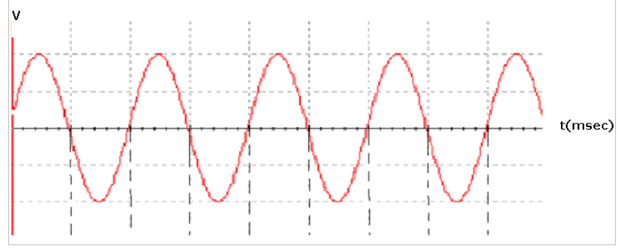

**PRECAUTIONS:**

The connections are to be connected properly.

Transistor terminals should be identified properly.

Readings should be taken without parallax error.

**Analysis**:

**RESULT:**

**Applications:** Applicable to obtain periodic output signals of high frequency.

Colpitts Oscillator using surface acoustic wave devices can be used to produce useful sensors like temperature sensors and audio sensors.

Applicable in circuits where a huge frequency range is used.

**VIVA QUESTIONS**:

What are the applications of LC oscillator?

What type of feedback is used in oscillators?

What is the loop gain of an oscillator?

What is the difference between amplifier and oscillator?

What is the condition for oscillations?